This buck converter is used to take the output of the previous buck converter and drop it down from 12 V to 5V. The converter used was the MPM3620A – SYNCHRONOUS STEP-DOWN MODULE WITH INTEGRATED INDUCTOR.
Datasheet: monolithicpower.com/en/documentview/productdocument/index/version/2/document_type/Datasheet/lang/en/sku/MPM3620AGQV-Z/document_id/2100/

We used the schematic given on the datasheet for the 12-5 V stepdown for the calculations
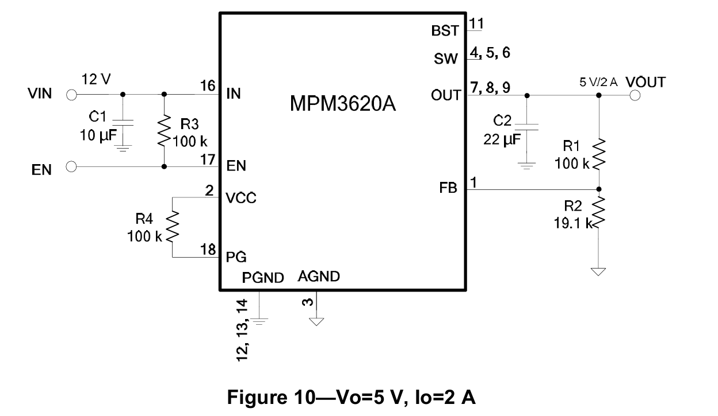
The max input from the PI Pico was 1.2 A and the max from the radios was 0.6 A so we made the max current with overage 2A. We found that the efficiency at 2 A was 90% from page 6 of the datasheet.
Component Values:
- Cin1 = 10 uF
- C_out1 = 22 uF
- R5 = 100 kO
- R6 = 100 kO
- R7 = 100 kO
This buck converter worked itself but the power board did not have enough protections for when the battery was first connected causing there to be too big of an initial current flow which caused the converter to spark.

